Introduction to programming in Java

1. **SETUP THE JAVA DEVELOPMENT ENVIRONMENT.**  
   Visit the website [www.oracle.com](http://www.oracle.com/) and go to ***Downloads*** section and download the Java Development KIT (JDK ) siutable for your operating system.  
   It could be JDK in version 6 and above. (In case Win OS just click next, next up to finish the installation, usually it’s catalog like „C:\Program Files\Java\JDK6_25”

You may change it to for example „C:\Program Files\Java\JDK6”

1. **SETUP PATH VARIABLES.**

After download and install the JDK you must set **PATH** and **JAVA_HOME** variables.

On Win OS go to *START --> My Computer* right click properties it’s look very simillar to screen below

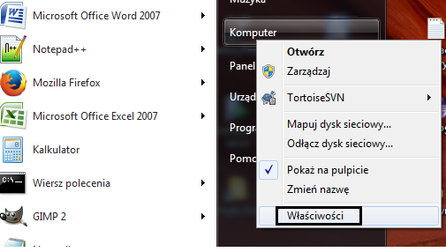

Then click **ADVANCED SYSTEM SETUP**

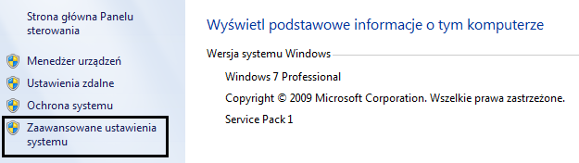

And after that click on **„PATH VARIABLES”**

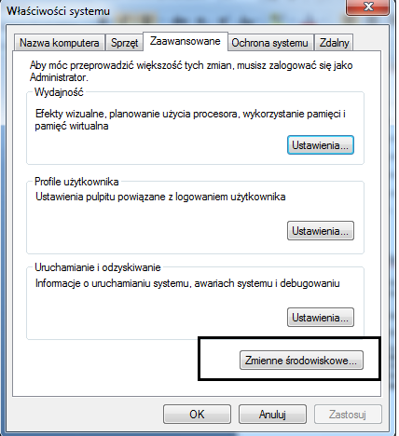

Depending on what kind of privileges you have you may set those variables for whole system or for current user. Setup **JAVA_HOME** variable for whole system, click **„NEW..”** in system variables.  
Enter the following data:  
  
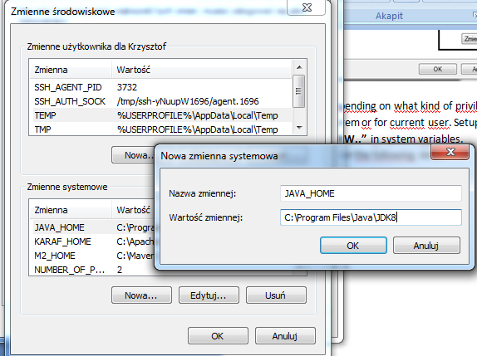

Path name – **JAVA_HOME** (All written with capital letters)

Path value –{ *full path to your Java install dir }* In this case **„C:\Program Files\Java\JDK8”**

Now it’s time to setup **PATH** variable, this variable may exist. If variable exists you must edit this variable and add the following entry  
**%JAVA_HOME%\bin;** it’s good to add also a . (dot) to the PATH variable, which means current directory is in PATH. In that case our entry look like follows **%JAVA%\bin;.;**

1. **Install Integrated Development Environment (in this case Eclipse)**

Integrated Development Environment is called IDE (shortcut). There are couple popular IDE’ like:

* Eclipse
* InteliJ
* NetBeans
* JDeveloper

Please visit website <https://eclipse.org/> and go to section download, try to find **Eclipse IDE for Java Developers** or **Eclipse IDE for Java EE Developers.**After download, unzip the file for your suitable location and run eclipse.exe (Win Os).

When prompt the window with question about default **Workspace** click OK.  
After Eclipse IDE window full appear, click from toolbar menu  
WINDOW -->Preferences

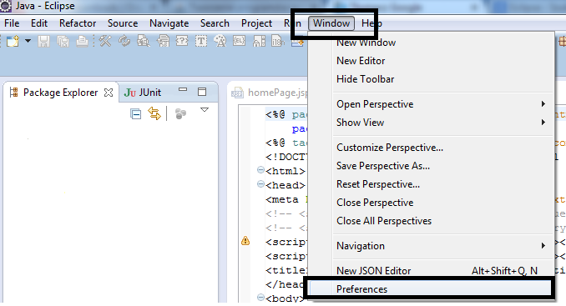

When another window will appear, enter the caption „JRE” into serach.  
After that you should choose manually „**INSTALLED JRE”** and click **„ADD”** and choose **„Standard VM”** click **NEXT** and after that choose **„DIRECTORY”** and go to location the same like **„JAVA_HOME”**  and change the name of the JRE. All should look like on the screen below.

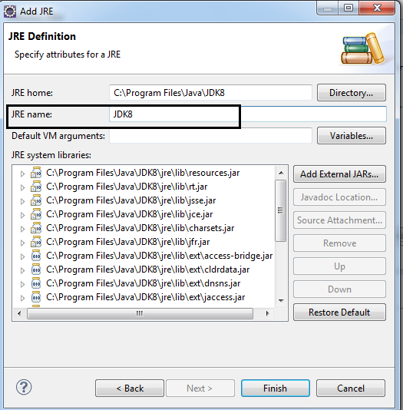

Click **Finish,** after that OK and that’s all ☺

YOU HAVE COMPLETED TO SETUP JAVA ENVIRONMENT AND IDE – Congratulations!  
 YOU MAY WRITE NOW YOUR FIRST JAVA APPLICATION!